Word Rhyme Assessment
Name: ____________ Date:___________

Rhyme of the Week: ______________ Rubric Level:__________

- Show the vocabulary cards of the rhyme and ask, “Can you say these words in English?”

Response:

- How do these words end? (gives rhyme) _______________________________

- Give me a word that rhymes with __________:

Response:

Circle One:
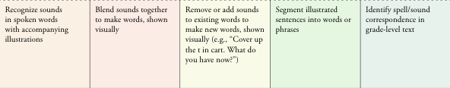

Teacher Observations/ Next Steps:

